# CoreLex Basic Types

Basic types in CoreLex point to synsets in WordNet. Most basic types point to one synset, but some point to multiple synsets.

## Legacy CoreLex and WordNet 1.5

Basic types were defined by looking at the ontological domains for nouns in WordNet 1.5. There were 11 of those domains, each starting a subtree of synsets. For five of those trees further basic types were defined from subtypes (sub synsets) in WordNet: entity (ent), abstraction (abs), group (grp), phenomenon (phm) and location (loc).

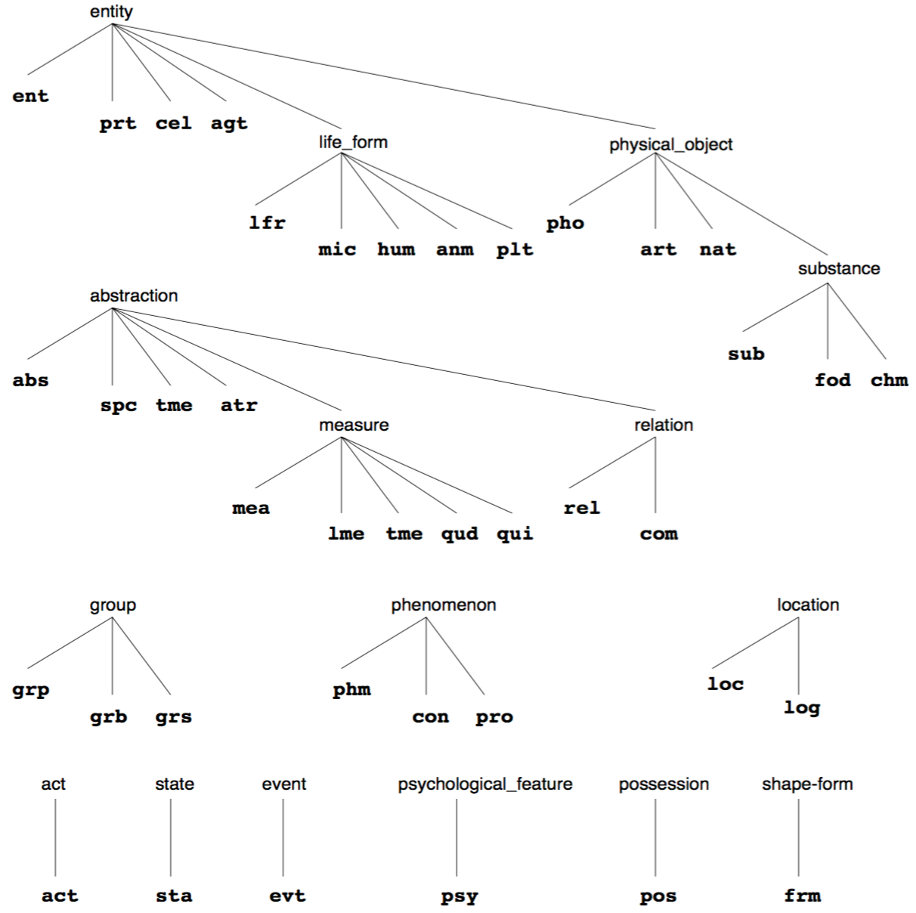

Note the notation used above. The basic type associated with a synset are printed as the first sibling, for example, the grp basic type points to the group synset. Siblings of the grp/group type/synset or printed to the right, positioned somewhat lower.

Here is a list of all basic types, with the synsets that they point to, and followed by the number of nouns that are of that basic type. What is listed are the nouns that occur in the synsets that the type points to, and those nouns can come from more than one synset. For example, the chm type points to two synsets: {compound chemical_compoud} and {element chemical_element}. This is shown with a dash in the table.

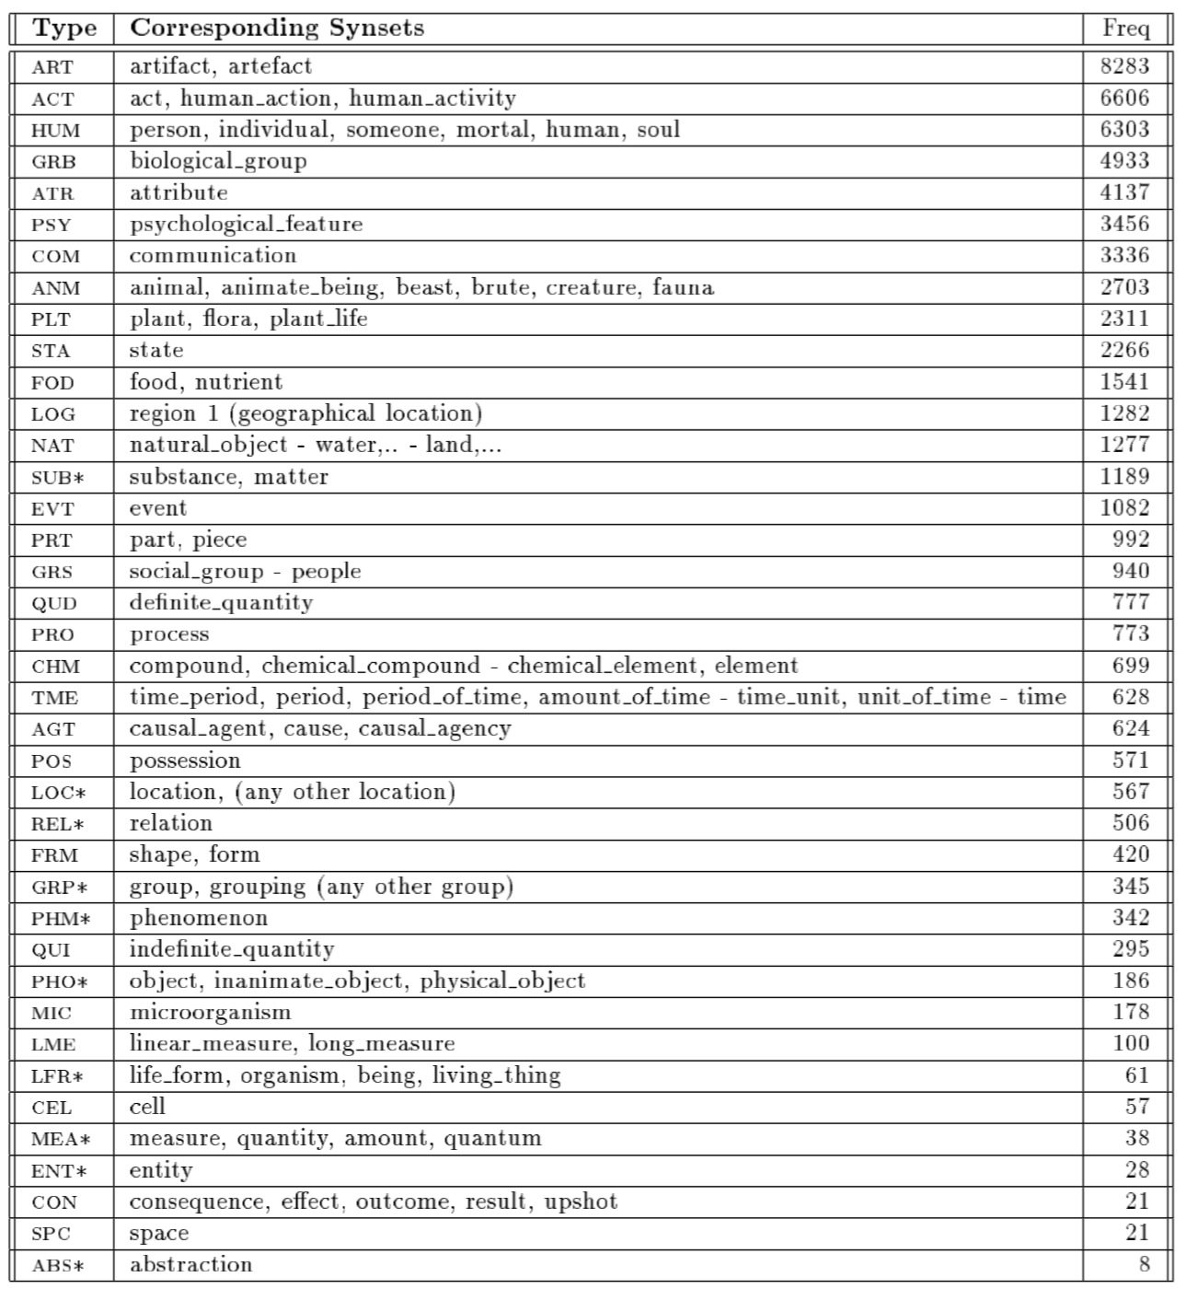

Basic types printed with a star are basic types that subsume other basic types. Nouns that are of a basic type x are counted under that type, unless the noun is also of a basic type y that is subsumed by x.

## CoreLex2 and WordNet 3.1

The WordNet hierarchy for nouns changed dramatically from version 1.5 to 3.1. In addition, some synsets were expanded or even split into multiple synsets. As a consequence, the mapping from basic types to synsets was revisited manually. The following figure has an overview of all basic types in the new WordNet hierarchy.

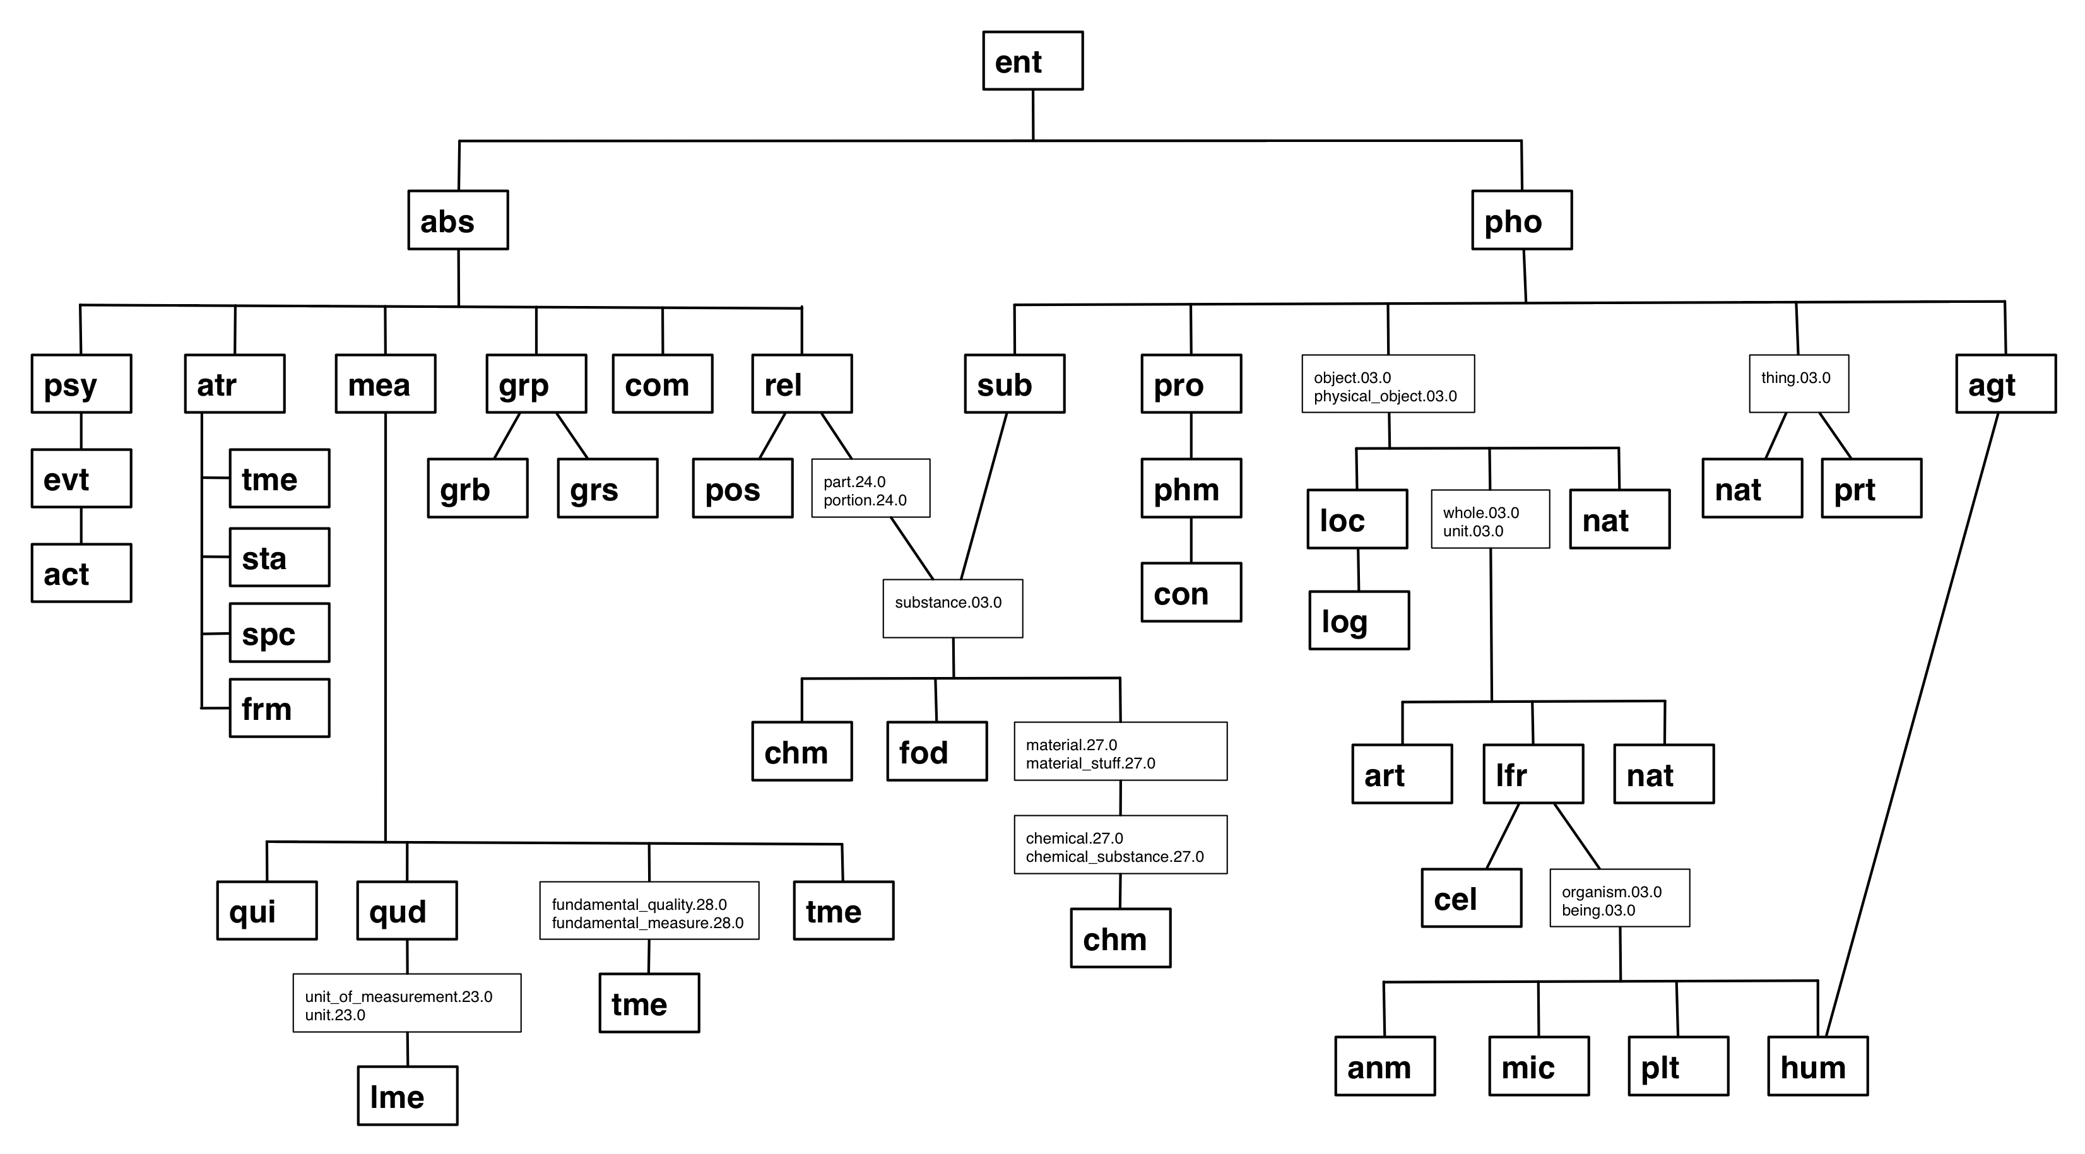

In some cases there are intervening WordNet synsets between some basic type and a basic type in the hierarchy. In those cases the synset is printed as it occurs in WordNet. For example, the nat basic type is subsumed by pho, but in between is the {thing.03.0} synset (the font is rather small, there are more detailed graphs of sub trees of the whole tree that have a bigger font and that print more details). Note the 03.0 in the representation of the synset. The 03 refers to a particular lexicographers files that is used when WordNet is created. There are a 45 of those files and they tend to group synsets along syntactic category and certain logical groupings like actions, animals and artifacts. The 03 file is for nouns that are top elements in the hierarchy (these could be several levels deep though). The 0 in 03.0 refers to a unique sense in the file.

Another thing to note is that multiple inheritance now plays a role. The basic types chm and fod are subsumed by both relation (rel) and substance (sub), and therefore by abstraction (abs) and physical object (pho). Similarly, human (hum) is subsumed by both life form (lfr) and agent (agt).

The following two images show the hierarchy under abstraction is some more detail. For each basic type the WordNet synset is now included.

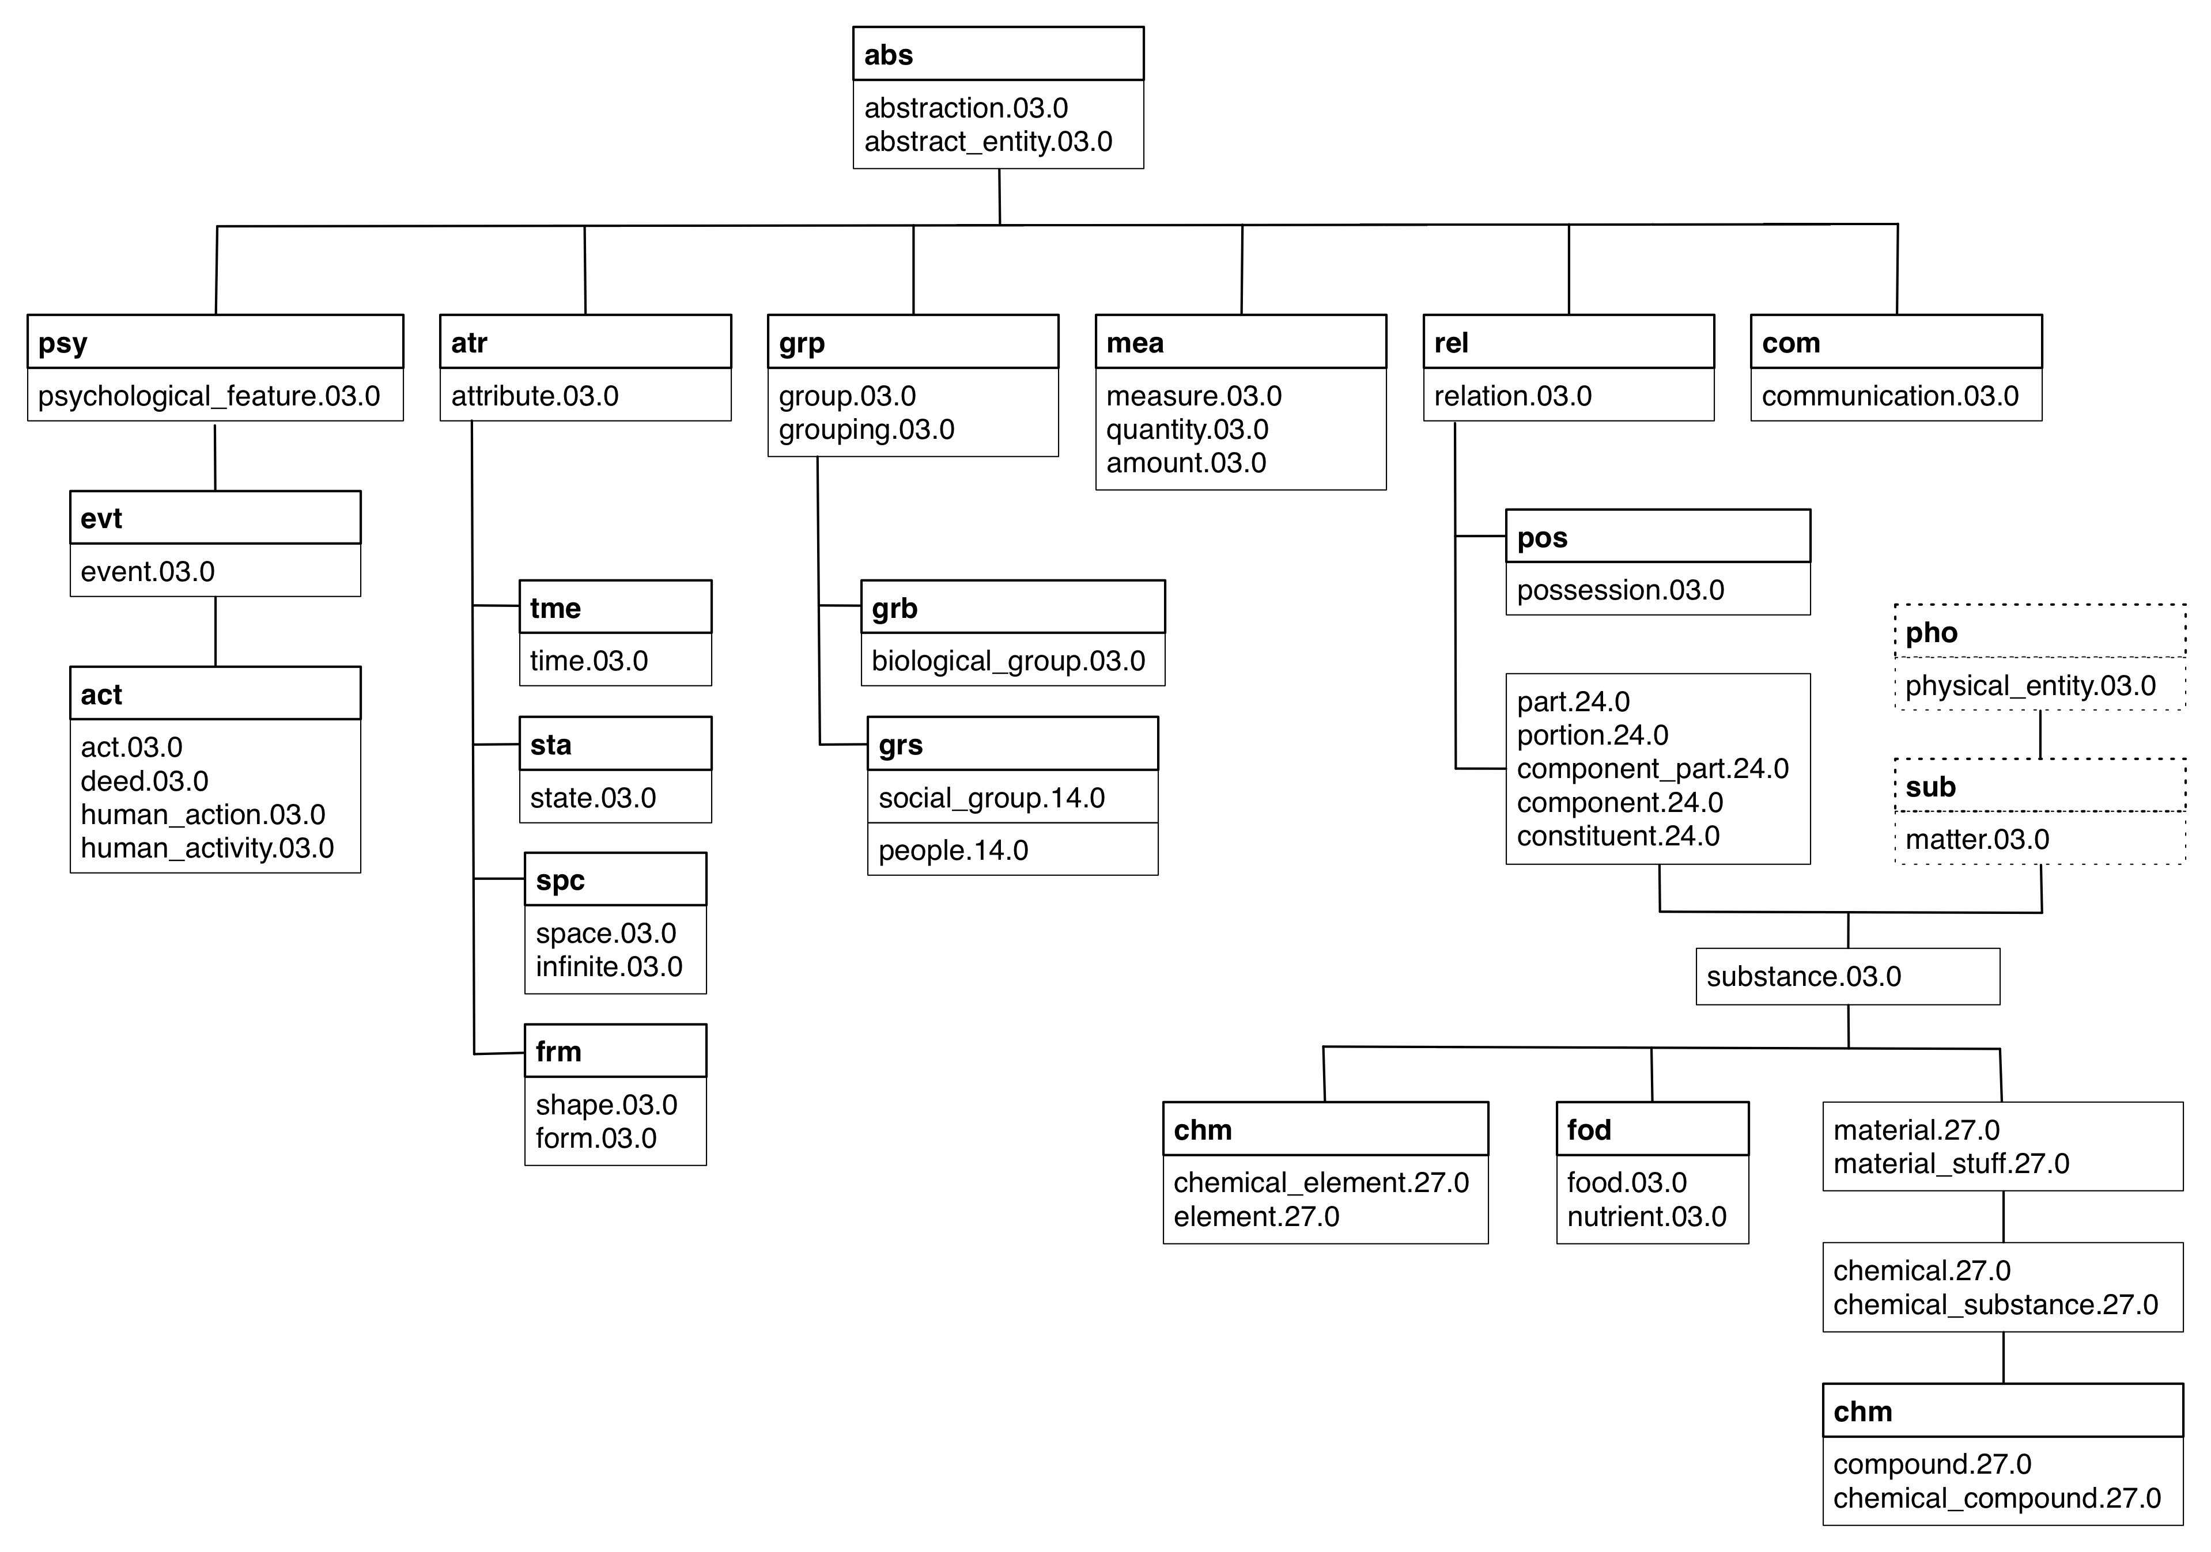

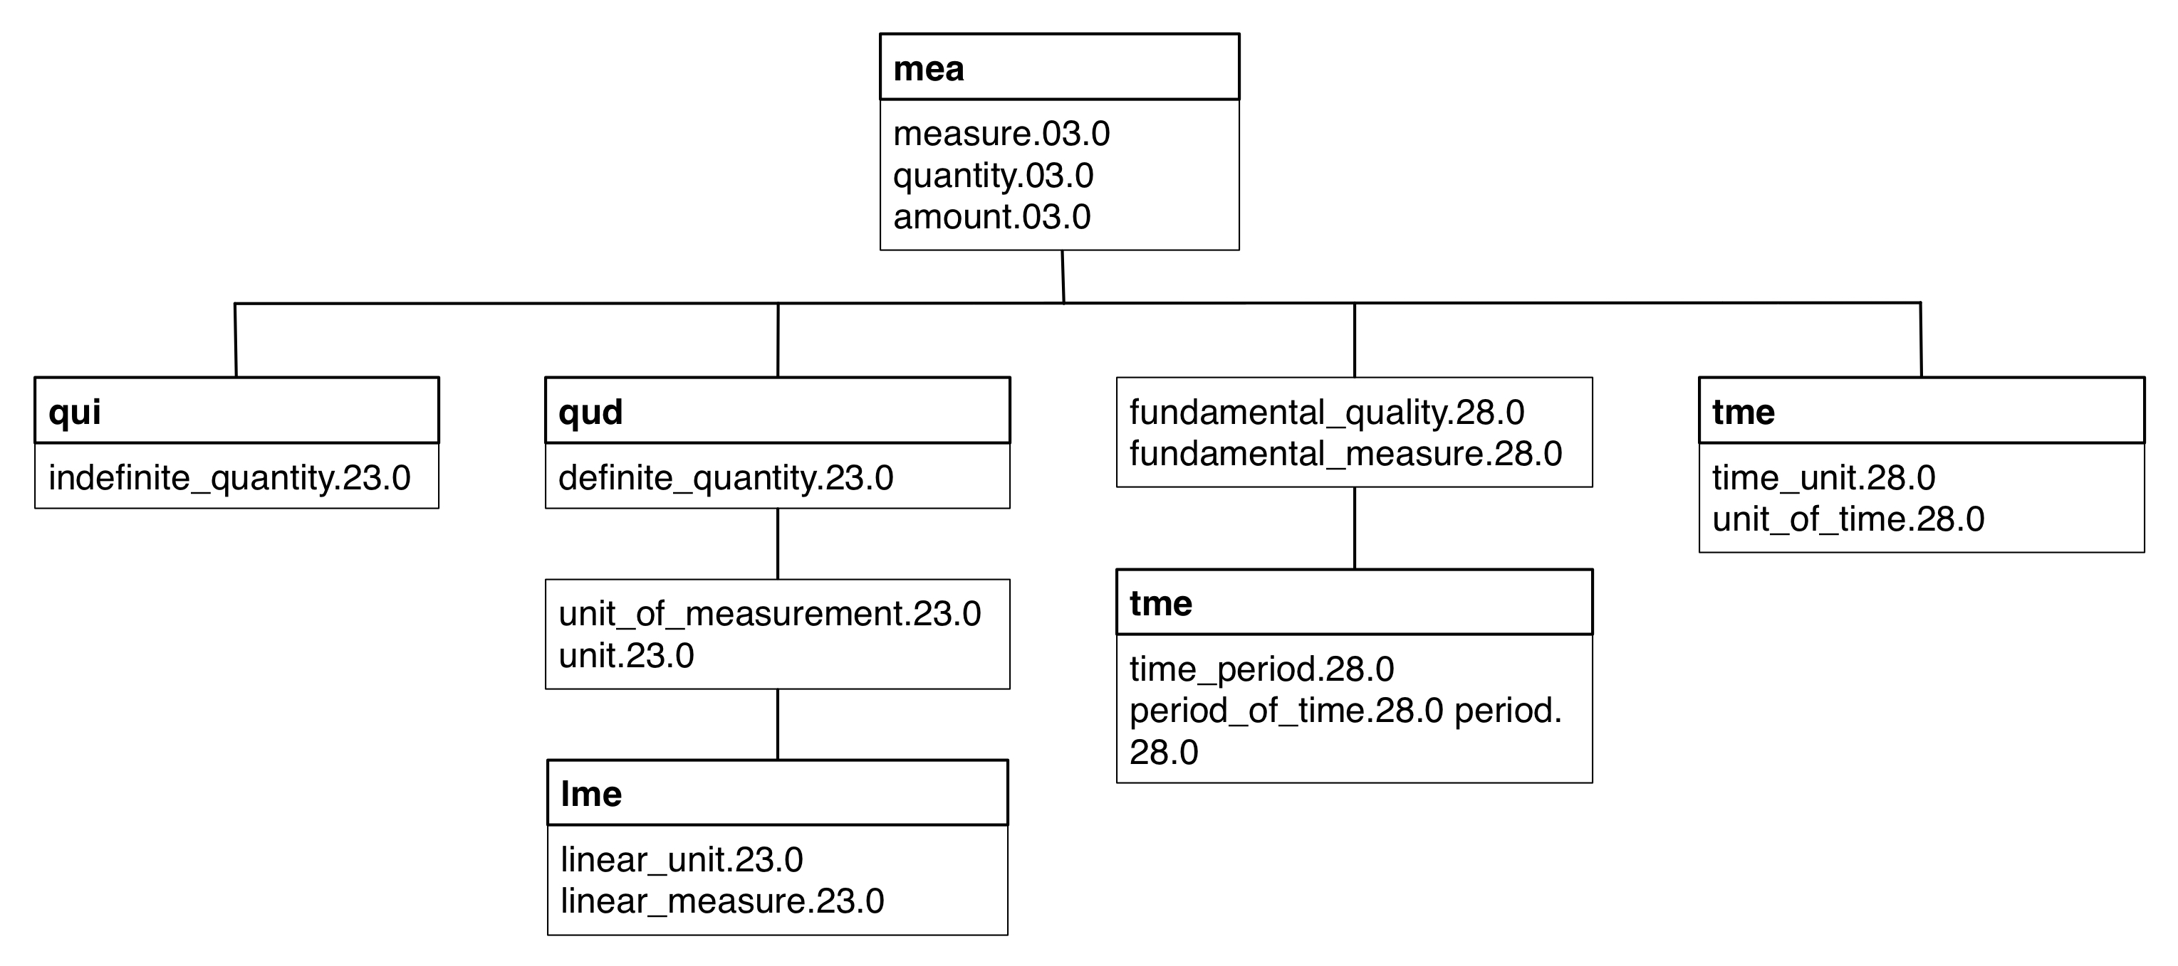

Notice again how fod and chm also inherit from non-abstract types.

Finally, here is a detailed picture of the physical object hierarchy.

